Optimizing a Volleyball Serve Through Physics Models

**Personal Engagement:**

This Physics Internal Assessment (IA), will explore the optimization of my volleyball serve. Volleyball is a sport that is dear to my heart. I have been playing since grade 9, was voted MVP for 2 straight years, and chosen captain of my school team this year. Being an undersized volleyball player has given me reason to focus tremendous energy on my technique to compensate for my height. This desire to excel in the sport of volleyball is the driving force in my IA. Through various experiments and analysis, I will examine the physics of my volleyball serve and its influencing factors, with the aim to optimize my volleyball serve.

**Background Research:**

For this assessment, three models are examined: a model that experiences the force of gravity; a model that experiences the forces of drag and gravity; and a model that experiences the forces caused by the angular velocity of the ball, drag and gravity. Examining the angular velocity of the ball uses Bernoulli’s Theorem, which states that in any fluid, in this case, air, that areas of higher velocity will have lower pressure and vice versa. With this uneven distribution of pressure, areas of high pressure will move to areas of low pressure. In the case of a ball that has no spin, as observed in Figures 1.1 and 1.2, assuming even air pressure, there will be no deviation from the ball’s expected path. In Figure 1.2, the small black lines represent the air moving past the ball.

**Air Pressure:**

**Drag and Gravity Model**

**Free Body Diagram:**

**Drag and Gravity Model**

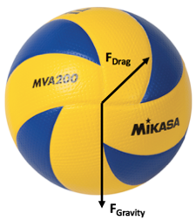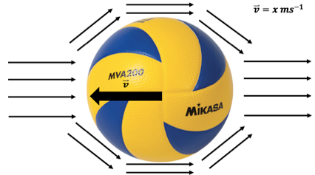

**Figure 1.1**

**Figure 1.2**

However, when spin is taken into account, there will be an uneven distribution of air pressure, this will change the trajectory of the ball. In volleyball, when angular velocity is applied to a ball, it is most often “top spin”, where the top of the ball has velocity in the same direction as it’s horizontal velocity. In Figures 1.3 and 1.4, the effects of this can be observed.

**Air Pressure:**

**Spin, Drag and Gravity Model**

**Free Body Diagram:**

**Spin, Drag and Gravity Model**

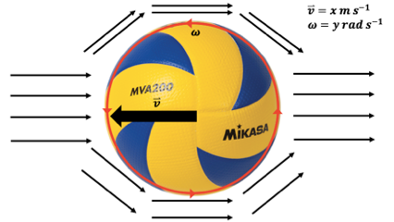

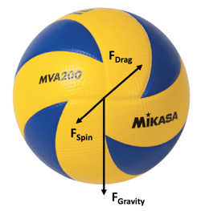

**Figure 1.4**

**Figure 1.3**

With spin added to the model, there is an additional force acting downwards and forwards on the ball. At the bottom of the ball, the air is moving with the ball, causing the air to have a higher velocity. According to Bernoulli’s Principle, since the air is moving faster, it has a lower pressure.[1] At the top of the ball, the air is moving in the opposite direction of the ball, causing it to have higher pressure.[2] Since areas of higher pressure move to areas of lower pressure, there is a downward and forward force acting on the ball. In volleyball terms, this means that the ball can be served at a steeper trajectory and with more speed since the force acting downwards on the ball can keep it in play.[3] The effect of this force will be determined by using the equation:[4]

Where:

is the force caused by the spin of the ball;

$K_{s}$ is the proportionality constant of spin;

$ω$ is the angular velocity of the ball; and

$v$ is the velocity of the ball relative to the air.

This can be broken down into its horizontal and vertical components to determine its projectile motion. However, of important note, the force due to the spin is perpendicular to the motion, so for the force of the spin acting in the y-direction, the x-component of velocity must be used to calculate it, this is the same for the force acting in the x-direction. The proportionality constant of spin, $K_{s}$, can be determined by rearranging the equation above:

$$F_{x}=K_{s}ωv_{y}$$

$$a_{x}=\frac{K_{s}ωv_{y}}{m}$$

Since the acceleration of the ball caused by drag is much smaller than that of gravity: $v_{y}=-gt$

$$a_{x}=\frac{-K_{s}ωgt}{m}$$

This equation can then be integrated twice to yield:[5]

Where:

is the horizontal position of the ball.

Using this equation and an experiment where the angular velocity of the ball is changed and the deflection is measured, the proportionality constant of spin can be determined.

Drag is a force that opposes the movement of an object through a fluid. In this case, the fluid being used is air, and the object is a ball. Drag is calculated using the following equation:[6]

Where:

is the density of the air;

$v$ is the speed of an object relative to the ground;

$C_{D}$ is the drag coefficient of the volleyball; and

$A$ is the cross-sectional area of the volleyball.

The drag coefficient cannot be accurately calculated with the equipment to which I have access. As such, I will use the value 0.36 that was already calculated for a volleyball[7]. This value is expected, as the drag coefficient for a sphere should be between 0.3 and 0.4.[8] In drag, there are two forms of drag that affect the force acting on an object: skin friction, the air moving against the object; and form friction, the force caused by the turbulence behind the object.

To determine the angular velocity of the ball, the angular momentum of the ball can be used. The angular momentum is calculated by using three base trials to determine the transfer of angular momentum from my arm to the ball, and using that to determine the angular velocity of the ball. The angular momentum of an object is calculated by first determining the moment of inertia. For a hollow sphere, the moment of inertia is calculated using the formula:[9]

For an arm (Pendulum of even mass distribution):[10]

Where:

𝐼 is the inertial moment;

𝑚 is the mass; and

𝑟 is the radius of the ball.

Knowing this, it is possible to determine the angular velocity of the ball using the angular momentum equation.[11]

Here are the dimensions for a regulation Federation International de Volleyball (FIVB) volleyball court that will be used for this assessment:

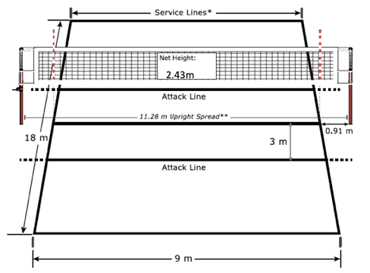

Baseline

**Research Question:**

Between the model incorporating the force of spin, drag and gravity; the model for drag and gravity; or the model for gravity, which ball will impact the end line of the volleyball court in the shortest amount of time?

**Hypothesis:**

The model that incorporates the force of spin will impact the end line of the volleyball court first. This is because, the force of spin acting on the ball will oppose the force of drag acting on the ball, causing it to accelerate faster to the ground.

**Variables:**

All serves that are preformed and used in the simulations are what are known as jump serves. Where the player tosses the ball and then jumps to hit it.

**Main Simulation:**

|  |  |  |
| --- | --- | --- |
| **Independent** | **Dependent** | **Controlled** |
| Forces acting on the serve (spin, drag, gravity) | Distance from net (ball impact point) | Height of impact (2.90m) |
| Ball mass (270g) |
| Air pressure (ball) |
| Serve location/direction (baseline, perpendicular to service line) |
| Ball initial velocity (28.02m/s) |

**Assumptions:**

**Even air density/pressure:**  During the calculations and experimentation, it was assumed that, other than the difference in air pressure caused by the rotation of the ball, the air pressure was constant. This is a variable that is very difficult to control let along measure, so it is assumed that the density of air is even throughout all trials. However, given that most differences with this are already neglected with spin trials and only slightly affect the trajectory of balls with no spin, air density/pressure can be ignored.

**No wind:** For this experiment and for the simulation, it will be assumed that there is no wind that affects the trajectory of the serve, or the ball drop.

**Air humidity:** During the calculations and experimentation, it was assumed that the air density was small enough that it would not affect the calculations of the $K_{s}$ constant or the trajectory of the ball. This is difficult to take into account when preforming calculations, and any potential affects that it may have are not large enough so that it will have any major changes on the experiment.

$K_{s}$**Experiment:**

**Hypothesis:**

As the angular velocity of the volleyball increases, the deflection of the ball will also increase. As the angular velocity increases, so too does the difference in the pressure on different sides of the ball. This causes the areas of higher pressure to move to the areas of lower pressure. This increase in the difference in pressure causes a greater force to be applied to the ball, and increase the deflection.

**Variables:**

|  |  |  |
| --- | --- | --- |
| **Independent** | **Dependent** | **Controlled** |
| Angular Velocity | Deflection | Drop location |
| Ball mass (270g) |
| Air pressure (ball) |

**Apparatus: $K_{s}$ Experiment**

**Figure 1.6**

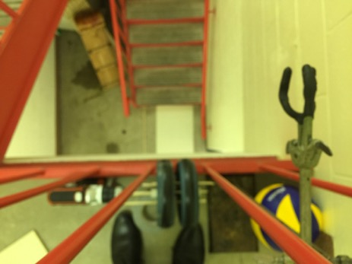

**5**

**4**

**6**

**1**

**2**

**6**

**3**

**8**

**Materials:**

1. Mikasa MVA 200 volleyball
2. Retort stand
3. Variable speed drill
4. 2 Wheels
5. Duct tape
6. 2 pieces of wood (One small, the other large)
7. Filming device
8. Meter stick

**Procedure:**

1. A large piece of wood was set approximately 4 m below the desired ball drop.
2. A meter stick was set beside it for scale in the analysis.
3. The drill was taped to the floor and the railing.
4. The drill was set so that it would spin the ball upwards.
5. A retort stand was set up so that it looked down on the drill assembly.
6. Filming device was attached to the retort stand and set to film in slow motion so that it could see the entire ball fall.
7. The ball was passed over the railing.
8. The ball was dropped against the drill without any spin to get the position of the landing of a ball with no spin.
9. Using the smaller of the two wooden planks, the ball was held in place against the drill.
10. The camera started recording.
11. The drill was then started at a slow setting.
12. Steps 3-7 were repeated five times, increasing the speed of the drill until it was at its maximum velocity.
13. The video data was taken into Logger Pro where the distance was set according to the meter stick at the bottom of the stair well.
14. The location of the balls at impact were recorded and analyzed in Excel.

|  |  |  |
| --- | --- | --- |
| **Angular Velocity (rad/s)** | **Deflection (m)** | $K_{s}$**(kg/rad)** |
| $$15±4$$ | $$0.01±0.02$$ | $$-0.0002±0.0005$$ |
| $$24±2$$ | $$0.12±0.02$$ | $$-0.0012±0.0005$$ |
| $$40±4$$ | $$0.06±0.02$$ | $$-0.0004±0.0005$$ |
| $$50±4$$ | $$0.18±0.02$$ | $$-0.0010±0.0005$$ |
| $$62±6$$ | $$0.21±0.02$$ | $$-0.0009±0.0005$$ |
|  | **Average:** | $$-0.0007±0.0005$$ |

**Analysis:**

**Figure 2.1**

**Figure 2.2**

**Generating Models:**

**Drag + Gravity:**

For solving the model of a volleyball serve undergoing the forces of gravity and drag, the coefficient of drag is required. It is possible to calculate the coefficient of drag experimentally by comparing the forces acting on a simulation and using a service machine, a mechanical device that serves the ball. This equipment is not available to me so a value that was already calculated will be used. The drag coefficient for a volleyball is 0.36.[12]

**Forces:**

The forces acting on the y-axis, are gravity and drag. This is represented by two equations:

While the ball is moving upwards:

$$F_{y}=-\frac{1}{2}ρ_{Air}v_{y}^{2}C_{D}A-mg$$

While the ball is moving downwards:

$$F_{y}=\frac{1}{2}ρ_{Air}v_{y}^{2}C_{D}A-mg$$

Since the velocity and drag act in opposite directions, there must be two equations to capture the vertical component of velocity changes.

For the forces acting on the x-axis, there is only the force of drag acting on the ball. Since the direction of the velocity never changes, the force acting on the ball is represented by the equation:

$$F_{x}=\frac{1}{2}ρ_{Air}v_{x}^{2}C_{D}A$$

**Position:**

To generate the position of the ball versus time, the x and y components of the forces will be placed into a simulation to generate positions. This will be done by using the acceleration, multiplying the acceleration by time to yield a velocity and adding the initial velocity, then taking the velocity multiplying it by time to yield a position and adding initial positions.

**Spin + Drag + Gravity:**

For solving the model of spin, drag and gravity, the process is very similar to that of the drag and gravity models, except that the force of angular velocity is added into the model.

**Force:**

As stated in the background research, the force of the spin acts perpendicularly to the velocity of the ball. The force caused by the x-velocity in the y-axis of the ball is calculated using the equation:

$$F_{s}=K_{s}ωv$$

$$F_{sy}=K_{s}ωv_{x}$$

The forces acting in the y-direction are represented by the two equations:

When the ball has an upwards velocity:

$$F_{y}=\frac{1}{2}ρ_{Air}v_{y}^{2}C_{D}A-mg-K_{s}ωv_{x}$$

When the ball has a downwards velocity:

$$F_{y}=-\frac{1}{2}ρ_{Air}v_{y}^{2}C_{D}A-mg-K_{s}ωv_{x}$$

The force acting in the x-direction is represented by the two equations:

When the ball has an upward velocity ($v_{y}$):

$$F_{x}=-\frac{1}{2}ρ_{Air}v_{x}^{2}C_{D}A-K_{s}ωv_{y}$$

When the ball has a downward velocity ($v_{y}$):

$$F_{x}=-\frac{1}{2}ρ_{Air}v_{x}^{2}C_{D}A+K_{s}ωv_{y}$$

**Position:**

The force equations are then placed into a simulation with the variables below. The angular velocity value is required to calculate the position. This is calculated by finding the transfer of angular momentum between my arm and the ball. The linear momentum of my arm is multiplied by its length to determine the angular momentum and therefore, the ball’s angular momentum. This yields the values below:

|  |  |  |  |  |  |  |
| --- | --- | --- | --- | --- | --- | --- |
| $$v_{ball}(ms^{-1})$$ | $$P_{ball}(kg ms^{-1})$$ | $$P_{arm}(kg ms^{-1})$$ | $$I_{ball} (m^{2} kg)$$ | $$L_{arm}(kg m^{2}s^{-1})$$ | $$L_{ball}(kg m^{2}s^{-1})$$ | $$ω_{ball} (rad s^{-1})$$ |
| 28.02 | 7.56 | 93.9 | 0.0018 | 63.8 | 0.110 | 61.1 |

Once the spin serve was optimized, its initial velocity and starting angle were then placed into the drag and gravity simulation and the gravity simulation. This yields the table of data below.

|  |  |  |  |  |
| --- | --- | --- | --- | --- |
| **Serve:** | **Initial Velocity:** | **Starting Angle:** | **Impact Distance:** | **Flight Time:** |
| Spin+Drag+Gravity | $$28.02 ms^{-1}$$ | $$0.07125 rad (4.08°)$$ | $$17.99 m$$ | $$0.83s$$ |
| Drag+Gravity | $$28.02 ms^{-1}$$ | $$0.07125 rad (4.08°)$$ | $$21.01 m$$ | $$1.01s$$ |
| Gravity | $$28.02 ms^{-1}$$ | $$0.07125 rad (4.08°)$$ | $$27.68 m$$ | $$1.00s$$ |

**Figure 2.5**

The ‘drag and gravity serve’ and the ‘gravity serve’ in Figure 2.5 are using the optimized angle and initial velocities of the spin serve. Using the optimized values of the spin serve shows how much of an impact the angular velocity of the ball makes on the trajectory of the ball. Under these conditions, it is impossible for the ‘drag and gravity serve’ or the ‘gravity serve’ to impact the baseline, assuming that the ball travels perpendicularly to the baseline. However, if the angle is able to change, for instance, the ball is hit into the far corner, it is possible that the ball will land in the court. When a serve is preformed from the starting serve position, 1 m from the right corner of the baseline to the opposite left corner, the distance is 23 m. However, there will still be a noticeable difference in the time between the impacts of the balls under different models.

**Calculations:**

**Proportionality Constant of Spin**

$$s_{x}=\frac{-K_{s}ωg}{6m}t^{3}$$

$$K_{s}=\frac{{-s}_{x}6m}{ωgt^{3}}$$

$$K_{s}=\frac{-(0.21±0.02)m*6(0.270±0.01)g}{(62±5)\frac{rad}{s} (\frac{9.81m}{s^{2}}){(0.65s±0.03s)}^{3}}$$

$$K_{s}= -0.00087±0.00023\frac{kg}{rad}$$

**Angular Velocity**

$$ω=\frac{2π rad}{T}$$

$$ω=\frac{2π rad}{0.102s}$$

$$ω=62\frac{rad}{s}$$

**Moment of Inertia Hollow Sphere (Volleyball)**

$$I=\frac{2}{3}mr^{2}$$

$$I=\frac{2}{3}(0.270kg)({0.10m)}^{2}$$

$$I=0.0018kg m^{2}$$

**Moment of Inertia Pendulum of Evenly Distributed Mass (Arm)**

$$I=\frac{1}{3}mr^{2}$$

$$I=\frac{1}{3}(3.65kg)({0.73m)}^{2}$$

$$I=0.65kg m^{2}$$

**Angular Momentum**

$$L=ωI$$

$$L=27.9 rad s^{-1}(0.0018 kg m^{2})$$

$$L=0.050 kg m^{2} s^{-1}$$

**Angular Velocity from Angular Momentum**

$$ω=\frac{L}{I}$$

$$ω=\frac{0.110 kg m^{2}s^{-1}}{0.0018 kg m^{2}}$$

$$ω=61 rad s^{-1}$$

**Evaluation:**

**Main Simulation:**

The serve that was determined to have the shortest flight time and that land nearest to the baseline within the court was the spin, ‘drag and gravity serve’. The main factor in this being the most optimal serve is the extra downward force that is caused by the angular velocity of the ball. This angular velocity causes a difference in air velocities on different sides of the ball. According to Bernoulli’s Principle, as the velocity of a fluid increases, its pressure decreases, and where the velocity is lower it has a higher pressure, creating a force between these two regions as the fluid tries to balance the pressure difference. In this case, there is a higher pressure on top of the ball causing both a downward and forward force on the ball. This makes a very significant difference in the motion of the ball as indicated in Figure 2.5 and a notable difference in time of 0.18s between the impacts of the spin serve, and the ‘drag and gravity serve’. All of these serves could be optimized so that they hit the opposite corner where there is a 23m distance instead of the 18m distance if the ball is hit perpendicularly to the baseline. However, this neglects the benefits of the spin serve in that it can be faster and land shorter than the ‘drag and gravity serve’ and the ‘gravity serve’. Included in the real-life aspects of this experiment are the limitations of velocity, jump heights and consistency that this lab can’t consider, but in terms of flight time, this shows that the optimal serve to use in volleyball is the jump spin serve. Another interesting optimization would be to study the shortest possible trajectory, whereby the ball just passes over the net and compare the times it would take to land. Further, in volleyball there is often “side spin” put on the service ball, which introduces a force moving across the ball so that it swerves away from or towards the passer. This would be interesting to investigate and expand into a 3D model.

Originally, I wanted to try to include the mechanics of an arm swing and how it affects the momentum of the ball and the serve. In the video of my fastest serve, the ball had a velocity of around $28 ms^{-1}$. When using the momentum of the ball and the calculations from trials of the transfer of angular momentum and regular momentum, the velocity of my arm during the swing was calculated to be $25.7 ms^{-1}$. This is fast, and in fact, far faster than any trial I attempted with my arm swing. Analyzing an arm swing is problematic due to the numerous variables that are difficult to quantify.

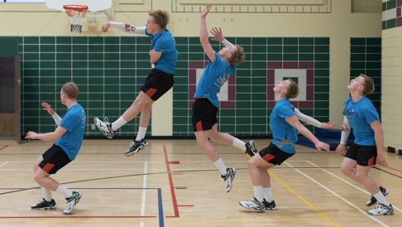

**Figure 2.6**

Image of me serving courtesy of Chris Miedema

As seen in Figure 2.6 above, there are many biomechanical factors that are acting on the serve of a volleyball. For instance, there is the torque of the body as the ball is impacted, the compression of the core muscles to accelerate the body through the ball, the arm swing its self, the run up etc. This makes the model too difficult to calculate, and made the connections between the arm swing and the transfer of momentum less meaningful. This is as there are numerous more factors that affect the momentum of the ball then are considered here. This lab could be improved by looking at some of the biomechanics and how that affects the service in volleyball.

An error that occurred during the analysis was that there was a lack of coherence between the angular momentum and the linear momentum. As stated in the background research, the relation between angular momentum and linear momentum should be: $L=p*r$, this will be referred to as the calculated angular momentum. The experimental angular momentum was calculated using the transfer of angular momentum from the arm swing to the ball. However, when the two angular momentums were compared, while they should have been equal, they were not.

|  |  |  |  |
| --- | --- | --- | --- |
|  | **Linear Momentum** | **Calculated Angular Momentum** | **Experimental Angular Momentum** |
| **Regular Hit** | $$3.22 kg ms^{-1}$$ | $$0.322 kg m^{2}s^{-1}$$ | $$0.0503kg m^{2}s^{-1}$$ |
| **My Fastest Serve** | $$7.56 kg ms^{-1}$$ | $$0.756 kg m^{2}s^{-1}$$ | $$0.110 kg m^{2}s^{-1}$$ |

This is indicative of a systematic error as the two angular momentums should be equal. When the calculated angular momentum is used, the angular velocities are impossibly high. For the regular hit: $179 rad{ s}^{-1}$, for my fastest serve: $420 rad s^{-1}$. The experimental angular momentum yields angular velocities of: Regular Hit: $27.9 rad s^{-1}$, My Fastest Serve: $61.1 rad s^{-1}$. These values are likely far closer to what the angular velocities are, versus the calculated angular momentum. The problem is likely in the video analysis software and the time scale it used. Furthermore, there are complicated biomechanics that go into a serve in volleyball. This is not included in the transfer of momentum calculations. This method could be improved by having a higher quality camera that can get a good view of the ball so that its angular velocity can be calculated.

$K_{s}$**Experiment:**

As was predicted in the hypothesis, as the angular velocity of the volleyball increased, so too did the deflection of the ball in the air. As the angular velocity of the ball increases so too does the difference in the velocity of the air on different sides of the ball. Based on Bernoulli’s principle, as the velocity of a fluid increases, its pressure decreases. On the other hand, as the angular velocity of the ball increases, air is slowed and deflected by the spin of the ball, this causes an increase in pressure. Since areas of high pressure will move to areas of low pressure there will be a force caused by the area of high pressure trying to balance the pressure with the areas of lower pressure. As can be observed in figure 1.4 this downward force on the ball will cause it to drop more quickly and allow for more initial force to be applied to the ball than was possible without the angular velocity. To calculate the effects of the angular velocity of the ball the proportionality constant of spin, $K_{s}$, is required. The constant $K_{s}$ was determined to be: $-0.0007±0.0005\frac{kg}{rad}$. This is used to calculate the projectile motion for the ball. The error on this value is very large and makes the spin serve in figure 2.5 very imprecise. This error could be reduced in the future by have a better and more stable apparatus so that there is less deviation in the trajectory of the ball that is not caused by the angular velocity of the ball. Also, having another person to mark the impact points of the ball could reduce the error.

A systematic error that occurred during the experimental data processing was that the $K_{s}$, the proportionality constant of spin, was not in fact a constant. There was significant change across each trial. The largest difference between two points being a difference of 6x from 0.0002 to 0.0012. This inconsistency seen in figure 2.1 should not be present, since the $K_{s}$ value is a constant. While slight deviation is expected, these larger deviations are concerning. However, saying this, when the value is averaged out, it is close to the experimental data from another lab conducted at [13] versus the $-0.0007±0.0005\frac{kg}{rad}$ determined in this lab, these values are quite close. As such, despite the values of the constant not in fact being constant, the final averaged value is likely close to being correct.

A systematic error that occurred during this experiment was when at higher angular velocities the ball was launched when released from the apparatus. This occurred when the drill was spinning upwards to apply a spin to the ball, this caused the ball to launch out when released, the ball travelled away from the drill in a forward’s direction. Since the proportionality constant of spin is higher than that of a similar experiment it would point to the launch increasing the deflation of the ball. This is supported by the fact that other $K_{s}$ is $-0.000659\frac{kg}{rad}$ rather than the $-0.0007±0.0005\frac{kg}{rad}$ of this experiment. However, with an error of 0.0005, there are many trends or values that could be supported.

Another systematic error that occurred during this experiment was the difficulty in controlling the angular velocity of the ball as it was being dropped. Since a variable speed drill was being used, it was possible to control the angular velocity to a certain degree. However, it was not possible to control the angular velocity so that all trials were the same or that there was a constant difference between separate trials. This just leads to the data being slightly less accurate and precise as there is a larger error on the angular velocity. This would lead to a less accurate trend as observed in figure 2.2. While the trend does not matter so much, the data points within it are needed to determine the proportionality constant of spin and the lack of precision and accuracy within this likely has a part to play in the deviation of the $K_{s}$ constant and the difficulty in generating a proper trend for this data. This could be improved by having a better apparatus, by using a motor to spin the ball whose angular velocity can be controlled via a computer better data could be collected to produce a better trend and $K_{s}$ constant.

**Conclusion:**

The serve that was determined to be the most optimal was the spin serve. This was caused by the difference in pressure between the top and the bottom of the ball because of the angular velocity. By doing so, there was a decrease in the travel time of the ball. Further, with the velocity that the simulations were set for, it was impossible for the other serves to land in the court if they were served perpendicularly to the baseline. It is possible for all serves to land in the court if the location that the ball is being served to is changed. However, the spin serve will always have the fastest time, and the shortest landing position. Some errors that occurred during this lab were that during the calculation of the $K_{s}$, the proportionality of constant of spin. During the experiment, there was difficulty controlling the angular velocity of the ball, this made “trial sets” difficult to determine, making the trends less accurate. Further, when the ball was being released from its apparatus, it often launched its self away from the apparatus, only to have the spin of the ball bring it back. This likely causing the $K_{s}$ to not be a constant. The large error on the $K_{s}$ caused there to be a significant error on figure 2.5 the projectile motion of the spin serve. This experiment could be improved in the future by considering the effect of the body’s biomechanics on the serve’s linear momentum and angular momentum. Using better cameras would allow for this experiment to have a better sense of the angular momentum of the ball. Another interesting addition would be to examine the effect of a “side spin” on the trajectory of a serve and modelling it in a 3D space. Further, by using a better apparatus for the $K_{s}$ experiment, the $K_{s}$ value could be more precise and accurate.

**Appendix:**

$K_{s}$**Raw Data**

|  |  |  |  |
| --- | --- | --- | --- |
| **No Spin** | **X position (m)** | **Y position (m)** | **Position (m)** |
|  | 5.90 | 2.92 |  |
|  | 5.93 | 2.81 |  |
|  | 6.06 | 2.78 |  |
| Average: | 5.96 | 2.84 | 6.60 |

|  |  |  |  |  |  |  |  |  |  |
| --- | --- | --- | --- | --- | --- | --- | --- | --- | --- |
|  | **t1 (s)** | **t2 (s)** | **T (s) (period)** | $ω\frac{rad}{s}$ | $x$**(m)** | $z$**(m)** | **∆t (s)** | **(m)** | $∆$**(m)** |
| **1st Spin** |  |  |  |  |  |  |  |  |  |
| **Trial 1** | 1.816 | 2.141 | 0.325 | 19.3 | 6.07 | 2.80 | 0.638 |  |  |
| **Trial 2** | 2.732 | 3.178 | 0.446 | 14.1 | 5.97 | 2.89 | 0.675 |  |  |
| **Trial 3** | 4.057 | 4.574 | 0.517 | 12.2 | 5.92 | 2.77 | 0.696 |  |  |
| **Average** |  |  | 0.429 | 14.6 | 5.99 | 2.82 | 0.67 | 6.62 | 0.014 |
| **2nd Spin** |  |  |  |  |  |  |  |  |  |
| **Trial 1** | 5.236 | 5.503 | 0.267 | 23.5 | 6.08 | 2.86 | 0.663 |  |  |
| **Trial 2** | 6.374 | 6.615 | 0.241 | 26.1 | 6.04 | 2.89 | 0.658 |  |  |
| **Trial 3** | 7.444 | 7.719 | 0.275 | 22.8 | 6.09 | 2.89 | 0.676 |  |  |
| **Average** |  |  | 0.261 | 24.1 | 6.07 | 2.88 | 0.666 | 6.720 | 0.118 |
| **3rd Spin** |  |  |  |  |  |  |  |  |  |
| **Trial 1** | 8.411 | 8.590 | 0.179 | 35.1 | 6.01 | 2.79 | 0.646 | 6.62 |  |
| **Trial 2** | 9.602 | 9.748 | 0.146 | 43.0 | 6.03 | 2.95 | 0.658 | 6.72 |  |
| **Trial 3** | 12.234 | 12.377 | 0.143 | 43.9 | 6.04 | 2.81 | 0.655 | 6.66 |  |
| **Average** |  |  | 0.156 | 40.3 | 6.03 | 2.85 | 0.653 | 6.67 | 0.065 |
| **4th Spin** |  |  |  |  |  |  |  |  |  |
| **Trial 1** | 10.802 | 10.94 | 0.138 | 45.5 | 6.11 | 2.94 | 0.642 | 6.78 | 0.180 |
| **Trial 2** | 5.67 | 5.787 | 0.117 | 53.7 | 5.46 | 2.98 | 0.638 | 6.22 | 0.214 |
| **Trial 3** | 6.916 | 7.036 | 0.12 | 52.4 | 5.45 | 2.83 | 0.554 | 6.14 | 0.147 |
| **Average** |  |  | 0.125 | 50.3 |  |  | 0.611 |  | 0.187 |
| **5th Spin** |  |  |  |  |  |  |  |  |  |
| **Trial 1** | 13.935 | 14.044 | 0.109 | 57.6 | 6.05 | 2.89 | 0.648 | 6.71 | 0.103 |
| **Trial 2** | 15.106 | 15.198 | 0.092 | 68.3 | 6.26 | 2.90 | 0.689 | 6.90 | 0.302 |
| **Trial 3** | 10.287 | 10.391 | 0.104 | 60.4 | 5.43 | 3.06 | 0.621 | 6.24 | 0.232 |
| **Average:** |  |  | 0.101666667 | 61.8 |  |  | 0.653 | 6.62 | 0.212 |

**Momentum Transfer Raw Data:**

|  |  |  |  |
| --- | --- | --- | --- |
| **Arm:** |  |  |  |
| $$v_{x arm} m s^{-1}$$ | $$v_{y arm} m s^{-1}$$ | $$v_{arm} m s^{-1}$$ | $$P_{arm} kg m s^{-1}$$ |
| 10.6 | 3.61 | 11.2 |  |
| 12.5 | 1.33 | 12.6 |  |
| 13.5 | -0.88 | 13.6 |  |
| 8.27 | 1.07 | 8.34 |  |
| 9.14 | 0.55 | 9.16 |  |
| 9.72 | 0.47 | 9.73 |  |
| 5.03 | 2.81 | 5.77 |  |
| 5.91 | 2.71 | 6.51 |  |
| 5.64 | 2.11 | 6.02 |  |
| 5.37 | 1.61 | 5.61 |  |
|  |  |  |  |
|  |  | 8.84 | 32.3 |

|  |  |  |  |
| --- | --- | --- | --- |
| **Ball Hit** |  |  |  |
| $$v_{x ball} m{ s}^{-1}$$ | $$v_{y ball} ms^{-1}$$ | $$v_{ball} m s^{-1}$$ | $$P_{ball} kg m s^{-1}$$ |
| 10.8 | -2.31 | 11.1 | 2.99 |
| 10.7 | -2.51 | 10.9 | 2.96 |
| 9.81 | -2.90 | 10.2 | 2.76 |
| 9.96 | -2.95 | 10.4 | 2.81 |
| 9.05 | -2.34 | 9.30 | 2.52 |
| 8.79 | -2.54 | 9.16 | 2.47 |
| 11.9 | -2.98 | 12.3 | 3.32 |
| 15.1 | -4.22 | 15.7 | 4.23 |
| 17.4 | -5.04 | 18.1 | 4.89 |
|  |  |  |  |
|  |  | 11.9 | 3.22 |

**Serve Simulation:**

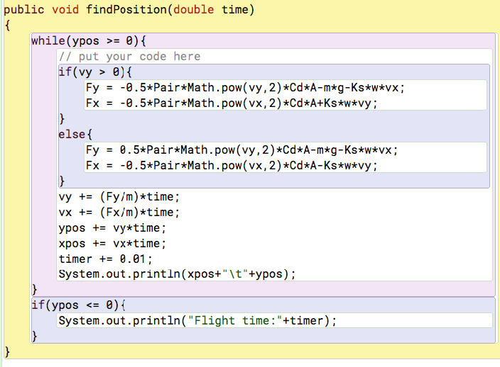

**Bibliography:**

Lithio, D., & Webb, E. (2006). Optimizing a Volleyball Serve. Rose-Hulman Undergraduate Mathematics Journal, 7(2). Retrieved from <https://scholar.rose-hulman.edu/cgi/viewcontent.cgi?referer=https://www.google.ca/&httpsredir=1&article=1246&context=rhumj>.

Angular velocity. (2018, March 03). Retrieved March 05, 2018, from <https://en.wikipedia.org/wiki/Angular_velocity>

Bernoulli's Equation. (n.d.). Retrieved March 05, 2018, from <https://www.grc.nasa.gov/www/K-12/airplane/bern.html>

Bernoulli's principle. (2018, March 04). Retrieved March 05, 2018, from <https://en.wikipedia.org/wiki/Bernoulli%27s_principle>

Density of air. (2018, February 25). Retrieved March 05, 2018, from <https://en.wikipedia.org/wiki/Density_of_air>

Fitzpatrick, R. (n.d.). Projectile Motion with Air Resistance. Retrieved March 05, 2018, from <http://farside.ph.utexas.edu/teaching/336k/Newtonhtml/node29.html#e5.27u>

List of moments of inertia. (2018, February 21). Retrieved March 05, 2018, from <https://en.wikipedia.org/wiki/List_of_moments_of_inertia>

Magnus effect. (2018, February 28). Retrieved March 05, 2018, from <https://en.wikipedia.org/wiki/Magnus_effect>

Relation of Angular to Linear Momentum. (n.d.). Retrieved March 05, 2018, from <https://ccrma.stanford.edu/~jos/pasp/Relation_Angular_Linear_Momentum.html>

The Drag Equation. (n.d.). Retrieved March 05, 2018, from <https://www.grc.nasa.gov/www/k-12/airplane/drageq.html>

Angular momentum. (2018, March 04). Retrieved March 09, 2018, from <https://en.wikipedia.org/wiki/Angular_momentum>

1. https://www.grc.nasa.gov/www/K-12/airplane/bern.html
2. Ibid
3. https://www.grc.nasa.gov/www/K-12/airplane/bern.html
4. https://scholar.rosehulman.edu/cgi/viewcontent.cgi?referer=https://www.google.ca/&httpsredir=1&article=1246&context=rhumj
5. Ibid
6. https://www.grc.nasa.gov/www/k-12/airplane/drageq.html
7. https://scholar.rosehulman.edu/cgi/viewcontent.cgi?referer=https://www.google.ca/&httpsredir=1&article=1246&context=rhumj
8. Ibid
9. https://en.wikipedia.org/wiki/List_of_moments_of_inertia
10. https://scholar.rosehulman.edu/cgi/viewcontent.cgi?referer=https://www.google.ca/&httpsredir=1&article=1246&context=rhumj
11. https://en.wikipedia.org/wiki/Angular_momentum
12. https://scholar.rosehulman.edu/cgi/viewcontent.cgi?referer=https://www.google.ca/&httpsredir=1&article=1246&context=rhumj
13. https://scholar.rosehulman.edu/cgi/viewcontent.cgi?referer=https://www.google.ca/&httpsredir=1&article=1246&context=rhumj.